**MatsyaSanskar: Enhancing Sustainability and Efficiency in Fish Farming**

Bhushan Chaudhari1* , Vaishali Chandrakant Bhadane2, Harshkumar Girish Bhamare3  Deepashree Nitin Patil4 , Meghana Bapu Gawali5

*1 (Associate professor, Dept of Information Technology SVKM’s IOT, Dhule India,* *chaudharibs@gmail.com*)*

*2345 (BTECH IV year, Dept of Information Technology SVKM’s IOT, Dhule India,bhadane025@gmail.com)*

**Abstract**

**Adopting modern techniques in fish farming presents several operational and financial hurdles, especially with routine tasks such as monitoring pH, temperature, and water quality, which often lead to increased labor costs. As the global population nears 7.7 billion, the demand for seafood escalates, positioning aquaculture as a vital means to meet this growing need. Conventional farming practices necessitate manual checks for oxygen levels, stress, and water conditions. An innovative approach involves the deployment of cutting-edge underwater sensors, including those for measuring temperature, turbidity, pH, total dissolved solids (TDS), and oxygen levels. These sophisticated devices are placed underwater to constantly gather accurate information on key factors like water temperature, clarity, pH balance, the amount of dissolved solids, and oxygen content. This data is then wirelessly sent to a central management system through Wi-Fi, enabling access from smartphones and computers. The system is designed to immediately notify operators of any irregularities, facilitating swift action to address potential problems. The primary aim of utilizing this advanced technology is to promote the growth of healthier fish, streamline operational expenses, and demonstrate a strong commitment to protecting the environment.This research paper contributes to the evolving landscape of aquaculture by presenting a comprehensive and technologically advanced solution to the challenges faced by fish farmers. The integration of IoT technology not only enhances the efficiency and sustainability of fish farming but also aligns with the growing need for environmentally conscious practices in agriculture. The findings of this research pave the way for a new era in fish farming, where data-driven decision-making and real-time monitoring become integral components of a successful and sustainable aquaculture industry.**

*Keywords —* *IoT-based aquaculture, Smart fish farming, Underwater sensors, Environmental stewardship, Real-time monitoring*

**I. Introduction**

With an environment of 7.7 billion people on Earth and growing, the world's inexhaustible demand for seafood highlights the critical role that aquaculture provides. But the traditional world of fish farming is wrapped in a network of financial and operational difficulties, especially when it comes to the demanding fishing process of farmers manually monitoring essential parameters like pH and temperature. The smart fish farming system powered that aims to completely transform the aquaculture industry in response to the environment. This study goes into unknown levels of innovation by seamlessly combining innovative digital underwater sensors. These highly developed sensors track the exact balance of temperature, turbidity, pH, and oxygen levels within the complex environments of fish farming with unique precision. Their combined efforts make them passionate supporters. of the development of sustainable aquaculture methods in addition to improving the overall health of aquatic life. The data collected by these innovative sensors connects smoothly via Wi-Fi modules all through the network to central control of the frame. By utilizing computers and smartphones, this coordinated operation makes sure that users may access information in real-time. This innovative system is more effective to others because it is proactive, quickly raising the alarm when irregularities are detected and enabling quick actions that improve operations. This study goes on an important process showing the many different kinds of advantages that arise from the well-balanced combination of IoT technology and fish farming. It highlights the production of more effective healthier fish and highlights the significance of cost-effectiveness and constant commitment to environmental sustainability as a result. These IoT-based solutions, launching in an exciting new phase in sustainable fish farming practices and ultimately affecting the future of our constantly evolving aquaculture landscape through the combination of modern technology with traditional aquaculture methods. According to the pie chart, 58% of IoT-based farming research is focused on solution proposals, with no articles reporting field experience. Research on validation makes up 26% of the total, while research on evaluation makes up 13%. Only 3% of research involves verification.

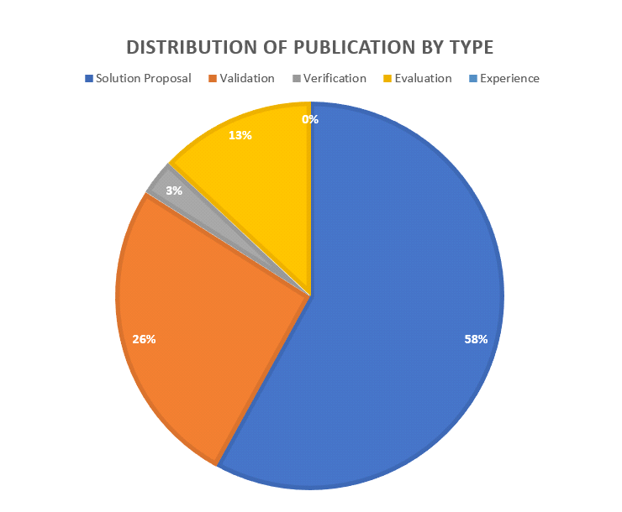

Figure 1 Distribution of Publication by Type[2]

**II. Literature Survey**

Aquaculture, the controlled cultivation of aquatic organisms, stands as a crucial contributor, accounting for approximately one-third of the total global fisheries production. This method of fish farming utilizes diverse environments, including saltwater and coastal ecosystems, employing cages in open waters and ground ponds. The promotion of aquaculture as a self-sustaining alternative to consuming wild fish underscores its potential to alleviate the pressure on natural fish populations. The primary objectives include reducing input data, such as feed, through efficient practices, maximizing outputs, and mitigating pollution by adopting carefully monitored and controlled practices, aquaculture seeks to emulate the delicate balance of natural ecosystems. The emphasis on sustainability is evident in its aim to lessen the environmental impact associated with traditional fishing methods. This involves optimizing feeding processes, managing stocking density, and implementing technologies to ensure efficient production while minimizing adverse effects on surrounding ecosystems. The overarching goal is to provide a stable supply of seafood, promote economic viability, and contribute to the global effort to create environmentally responsible food production systems [1] The paper states that this manual approach not only consumed significant time but also lacked the essential element of real-time monitoring. Prior models, including culture and forecasting models, failed to integrate online monitoring and real-time communication capabilities, leaving a critical gap in effective environmental surveillance.[2]The IoT-Based Knowledge-Based Immediate Fish Monitor System. Many studies focused on pH, DO, turbidity, and so on, and also on ways to solve such issues [5] [6] .That being said, realizing that the way of Internet of Things (IoT) may alter lives, the suggested system includes a wide range of sensors that can measure crucial parameters like temperature, pH, water level, turbidity, and the detection of motion. With an Arduino Uno's innovative structure, these sensors enable accurate and ongoing observations in the aquatic environment. What sets this architecture apart is its strategic reduction of internet consumption. Instead of relying on cloud-based solutions, the system employs a local database hosted on a dedicated computer system [3]An inherent emphasis on the interdependence of critical the system's encompassing approach is emphasized through the essential of fish growth. Beyond mere data collection, the proposed architecture integrates proactive measures, providing alerts and interventions when monitored parameters exceed predefined limits. This feature is particularly crucial for maintaining optimal conditions for aquatic life. IOT-based smart irrigation systems [7].We have concluded after extensive study that not all data need monitoring. We can infer the state of some parameters based on their quantity since certain parameters' imbalances can lead to the imbalance of other parameters. Temperature, pH, conductivity, and water colour are chosen operating parameters. We shall now discuss the causes of this. Chemical and biological processes are greatly affected by temperature. For every 10˚C increase in temperature, Chemical treatments are significantly impacted by temperature. Fish are not particularly resistant to sudden changes in temperature.[8] Fish can easily become affected or even destroyed by an abrupt reduction in temperature, even as low as 5˚C. The temperature falls inside the predicted range as a result. The typical limit temperature range of 21˚C to 33˚C is easily maintained.[9].The everyday existence of the fishery's aquaculture water is directly correlated with it. Fish health is significantly affected by very low water quality, which results in an overall reduction in fish productivity. Finally, it will become difficult to be able to determine the concentration of any particular ion in water. Conductivity can be detected with a conductivity monitor.[10].However, when the temperature and conductivity increase or decrease accordingly, DO decreases, consequently we are not collecting data on this. Once again, it changes similarly to the pH range [11], [12]. Therefore, if the temperature, conductivity, and pH level remain in balance, we can assume that the DO will be identical [13].Fishing and commercial fishing remain important sources of wholesome food, money, and financial security for hundreds of millions of people globally. Fish and other fishery products are now consumed on average more often worldwide thanks to significant advances in aquaculture and fisheries during the past 20 years. When the amount of fish raised for human consumption by the aquaculture industry surpassed the amount of fish harvested from the wild, it marked a turning point toward the significantly greater use of aquaculture species, particularly when compared to wild fish. The authors build employs sensors to gather data, machine learning to assess and make these decisions, and user alerts. The system design has been implemented to confirm and achieve a successful result.

The researchers produced a system that gathers sensor data, implements machine learning to determine the water status using substantial supervision via a mobile application, and provides significant supervision through a mobile application built by the researchers [14].

In this paper S. Ahmed, M. N. Islam, and M. S. Hossain probably give a comprehensive brief of the current status of aquaculture, considering its importance, difficulties, and technological developments. It would probably cover manual labour, conventional monitoring techniques, and the basics of automation technologies used in fish farming. The review will also go into detail on how emerging technologies, in particular the Internet of Things (IoT), are transforming several industries, including aquaculture. The authors may draw notice to the drawbacks of current solutions, such as their costly costs and limiting scalability, which would promote the invention of IoT-based systems[15].

Aquaculture Monitoring System possibly represents the creation of an advanced system for monitoring fish farms. It likely describes how they apply sensors for monitoring things like fish behavior and water quality, and also how they use the data to inform decisions. The approach was probably evaluated by the researchers to figure out how well it performs in actual fish farming situations. In general, the study certainly contains some useful details about how technology may improve fish farming techniques[16]. The introduction of a Raspberry Pi small computer as the primary device for data processing and control activities may be discussed in filled in this paper. The researchers will probably be discussing implementing different sensors to gather information on fish behavior, environmental factors, and water quality indicators. They could go further over how the Raspberry Pi connects to these sensors and enables data transfer to a cloud platform or central server [17]The research study can investigate the implementation of data analytics methods to evaluate the collected information as well as provide ideas to enhance fish farming methods. Overall, by proving how IoT could enhance aquaculture operations' productivity, sustainability, and efficiency,[20]the study may make significant contributions to the area of cultivation. The integration of Internet of Things (IoT) sensors allows for surveillance of feed consumption, environmental conditions, water quality, and other components of aquaculture. The researchers will also probably look into where blockchain technology can be used to build an open and secure system for sharing and recording data concerning aquaculture practices, including production and distribution. It's since emerging technologies can help solve issues with aquaculture management and expand the long-term sustainability goals of the agricultural industry[22],[23].

The study likely wants to provide optimal environmental conditions while improving overall production, minimizing resource consumption, and optimizing operational efficiency in aquaculture systems. With all factors considered, it might provide insightful knowledge on methods to use IoT technology to effectively and automatically control aquaculture environments to promote effective and sustainable fish farming methods[24]. To explore the potential benefits offered by IoT in improving these processes for sustainability and efficiency, the researchers can investigate a variety of issues including waste collection, division, recycling, and disposal. IoT has changed waste management techniques to improve both the environment and society.[26]

**III. Methodology**

The IoT-based smart fish aquaculture monitoring system's methodology takes a systematic approach to ensure precise and reliable water quality parameter monitoring. To gather representative data, the initial placement of IoT sensors for temperature, turbidity, pH, TDS, and oxygen concentration inside the fish farming environment is done strategically. These sensors need to be calibrated and maintained to provide accurate data over time. After that, an Arduino processes the data that has been gathered, computes the current values of the water parameters that are being monitored, and uses the Arduino IDE to display information in real-time. Following that, a threshold-based value concept is used to compare the processed sensor readings with standard values that have been set for each parameter. If any parameter exceeds its permitted range, an alarm is triggered. The information is stored in the cloud for further analysis assuring proactive and efficient water quality parameter monitoring to support the overall well-being and productivity of the aquaculture industry. To encourage sustainable aquaculture operations, this approach aims to give a comprehensive and reliable method for monitoring water quality indicators in aquaculture ecosystems.

*3.1 Algorithm for the proposed system*

1. Deploy Internet of Things (IoT) sensors to monitor pH, temperature, turbidity, and oxygen concentrations in the water in real time within the fish farming environment.
2. Arrange sensors in the environment of fish farming strategically.
3. Ensure the sensors are maintained and calibrated for precise readings.
4. Set up Arduino to process data.
5. Start the data gathering process:
6. Examine sensor readings for dissolved oxygen, temperature, turbidity, TDS, and pH.
7. Compute the current values of the parameters being monitored by processing the gathered data.
8. Use the Arduino IDE to display information in real-time.
9. Examine the processed sensor data in comparison to the preset standard values:
10. warning will sound if any parameter goes beyond the specified range.
11. Save the gathered information for later examination in the cloud.
12. Carry out the data gathering loop repeatedly and regularly.
13. End monitoring process.

*3.1.1Sensors Use*

|  |  |
| --- | --- |
| **Name of a sensor** | **Detects** |
| DS18B20 | Temperature |
| SEN0161 Dfrobot | pH |
| SKU SEN0189 | Turbidity |
| SEN0244 | TDS |
| SKU1356249 | Dissolved O2 |

*Table 1: Sensors Overview*

* + 1. *Temperature Sensor*

Temperature is an essential element that significantly affects chemical and biological processes. Though it is regulated and maintained within acceptable parameters, the temperature changes according to the type of fish. A DS18B20 temperature sensor is used in this study to monitor and maintain the water temperature in the fish pond between 26 and 32 degrees Celsius. This temperature sensor has good precision, requires few additional components, and is simple to connect to the microcontroller.

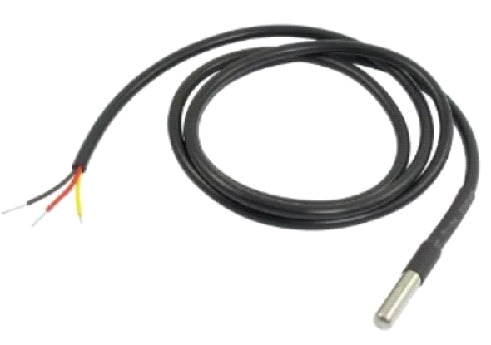

*Figure 2 Temperature Sensor*

* + 1. *Turbidity Sensor*

Turbidity measures the relative clarity of a liquid. The kind of turbidity that is there is indicated by the color of the water. Clearwater suggests limited biological production, making it unsuitable for fish. Green coloration is caused by algae, while brown coloration indicates the presence of clay. The water in the fish pond's turbidity rate or opacity is measured in this study using a turbidity sensor. The optical concept is effectively utilized by the turbidity sensor, which gauges the liquid solution's light transmission and scattering rate.

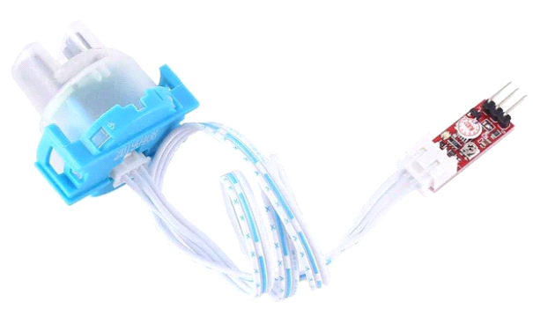

*Figure 3. Turbidity Sensor*

* + 1. *PH Sensor*

To accurately and consistently measure the pH of the water in a fish pond, a crucial part of the monitoring system is the SEN0161pH monitoring sensor. It is made especially for use in fish ponds and offers real-time data on water quality to support the growth and well-being of aquatic animals. Fish may survive in water that has a pH range of 4 to 10. However, sudden changes in pH can still kill fish, even within this range. The ideal pH range for fish is

6.5 to 9.0.

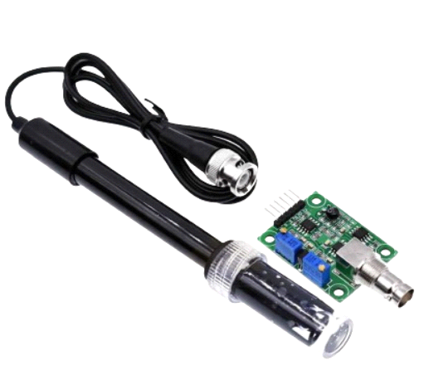

*Figure 4. PH Sensor*

*3.1.5 TDS sensor*

Fish pond monitoring systems can benefit greatly from the waterproof and long-lasting SEN0244 TDS (Total Dissolved Solids) sensor. This sensor, compatible with Arduino, operates based on conductivity and seamlessly integrates with Internet of Things (IoT) systems for monitoring. It accurately gauges the concentration of dissolved solids in water, which is crucial for sustaining a healthy environment for aquatic life. Providing up-to-date data on water quality, it helps in monitoring the Total Dissolved Solids (TDS) levels essential for the wellbeing of most freshwater species, ideally between 400 ppm and 450 ppm.

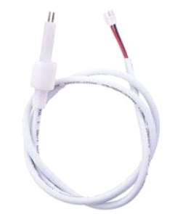

*Figure 5 TDS Sensor*

*3.1.6 Dissolved O2 Sensor*

The dissolved oxygen sensor plays an essential role in monitoring fish ponds, as it measures the amount of oxygen dissolved in the water. This sensor is key to ensuring the aquatic environment remains healthy by offering accurate and current information on water quality. Dissolved oxygen is often regarded as the primary metric for assessing water quality in aquaculture, with higher levels generally indicating better water conditions.

.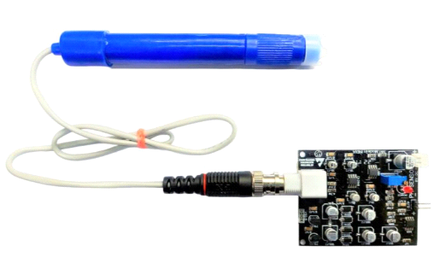

Figure 6 *Dissolved O2 Sensor*

*3.2 Architecture*

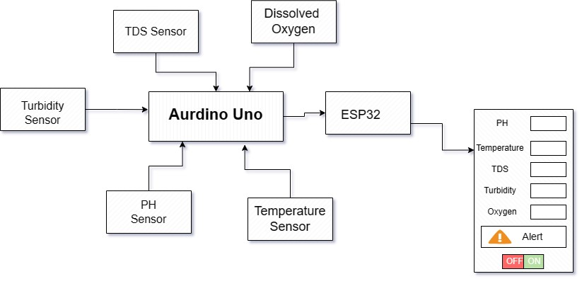

Figure 7 Architecture of model

*3.3 Sequence Diagram*

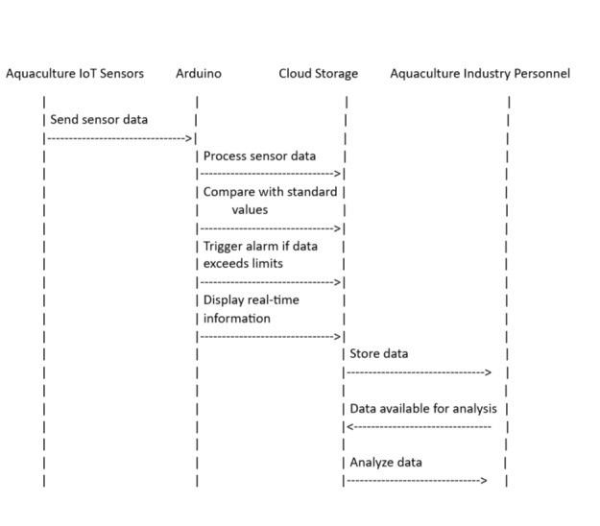

Figure 8 Sequence Diagram

**IV. Result and Analysis**

The implementation of Internet of Things (IoT) technology in aquaculture has led to innovative techniques for maintaining suitable water quality conditions, which are essential for the well-being and efficiency of fish farming processes. A common instance of this technology's use is the Smart Fish Aquaculture Monitoring System, a feature-rich system designed to continuously monitor and regulate the aquatic environment. This system effectively controls several critical water parameters, including temperature, turbidity, pH levels, and TDS sensor, all of which are necessary to maintain an environment that is suitable to aquatic life. With conducting real-time monitoring along with data analysis, the system makes sure that water quality parameters are kept within the necessary limits, so preserving the conditions necessary for fish farming..

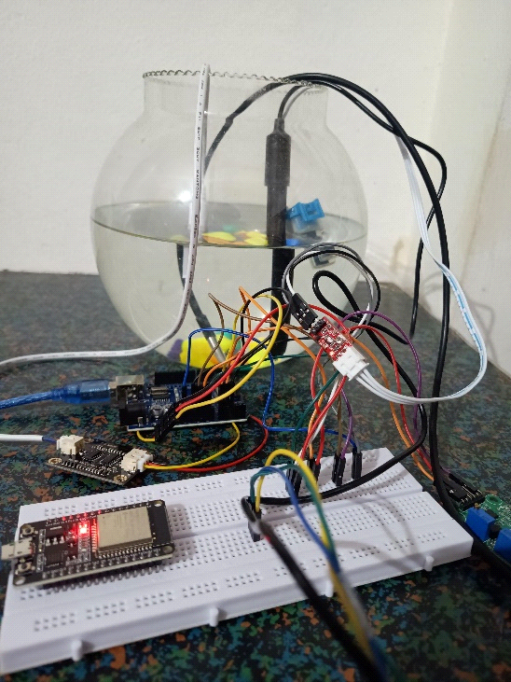

Figure 9 Prototype

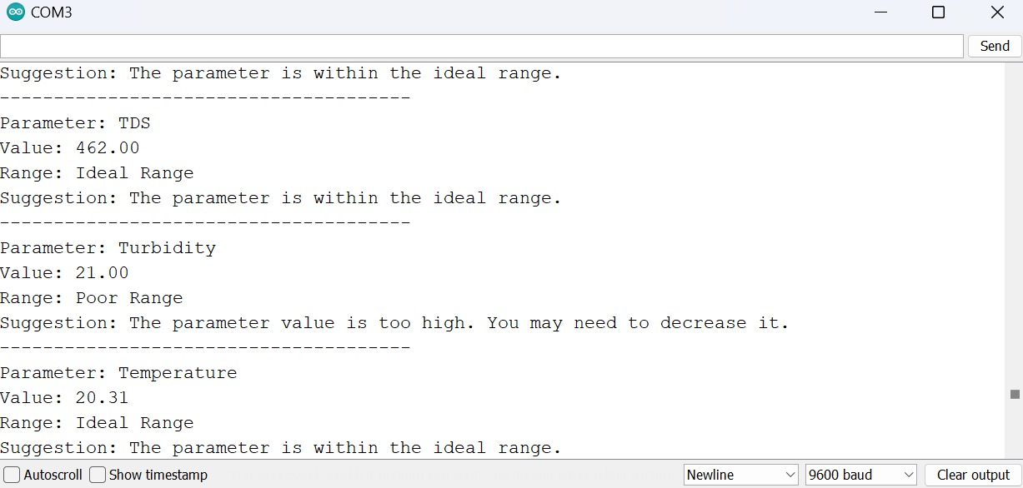

Figure 10 Output

Based on the experimental model, the real-time results are as follows.

|  |  |  |  |  |  |
| --- | --- | --- | --- | --- | --- |
| Day | Temperature (°C) | pH | TDS (ppm) | Turbidity (%) | Dissolved Oxygen |
| Monday | 28 | 6.1 | 410 | 45.2% | 3.4 |
| Tuesday | 27 | 7.1 | 430 | 45.1% | 3.1 |
| Wednesday | 29 | 6.6 | 420 | 45.5% | 2.9 |
| Thursday | 26 | 6.9 | 412 | 45.9% | 3.2 |
| Friday | 30 | 5.4 | 420 | 45.3% | 2.7 |
| Saturday | 28 | 6.8 | 415 | 45.4% | 2.1 |
| Sunday | 31 | 6.7 | 405 | 45.2% | 2.7 |

Table 2 Observation Table

The system's capacity to regularly record temperatures between 26 and 32°C, which is critical for maintaining the temperature within the aquatic environment, demonstrates how effective it is as an operational tool. Also, the system maintains pH values between 6.8 to 8.0, which is indication of an ideal aquatic environment. Total dissolved solids (TDS) monitoring is another important aspect of making sure the inorganic component content is kept under control. Readings of TDS generally range between 400 and 445 parts per million. Moreover, it was found that the turbidity levels were within the allowed range of 45%, indicating clear water conditions, which are essential for the health of aquatic life. The system regulates dissolved oxygen levels well, keeping them in the ideal range of 2.5 to 3.5, which is essential for the respiratory functions of aquatic life.

**V. Conclusion**

The conventional method fish farming's inefficiencies are overcome by the creative IoT-Based Smart Fish Farming System. In context of the increasing demand for seafood globally as well as the resulting costs of human surveillance, our research proposes a comprehensive system which combines digital underwater sensors and real-time analytics. This creative strategy maintains the fundamentals of conserving the environment while enhancing operational sustainability and efficiency. The research expands to the discussions on the use of IoT technology in agriculture by providing an integrated and scalable solution to fulfill the expanding demands of a rising world population, together with to having an use to fish farming. The system's effective implementation indicates an evolution toward data-driven decision-making, ensuring more stable sustainability of aquaculture, healthier fish, and lower costs.The highly efficient Smart Fish Aquaculture Monitoring System has shown to be beneficial in terms of keeping attention on and managing the critical water quality parameters of temperature, pH, turbidity, and TDS sensor. The effectiveness of aquaculture operations is directly impacted by these factors, which are essential for managing the health and security of aquatic life. Aquaculture has an endless opportunity for innovation particularly as technology keeps developing, indicating that the effectiveness and sustainability of fish farming methods will only increase in the future.The inefficiencies in conventional fish farming are addressed by the revolutionary IoT-Based Smart Fish Farming System. In light of the rising demand for seafood around the world as well as the costs associated with manual monitoring, our research suggests a comprehensive system that combines real-time analytics with digital underwater sensors. This creative strategy adheres to environmental stewardship principles while also improving operational sustainability and efficiency. In addition to its application to fish farming, this research advances the conversation on the use of IoT technology in agriculture by providing a significant and scalable means of satisfying the expanding needs of an expanding world population. The system's successful adoption marks a paradigm change toward data-driven decision-making, guaranteeing healthier fish, reduced expenses, and aquaculture's long-term viability.

**VI. Future Scope**

The future scope includes developing sensor capabilities for comprehensive data, creating partnerships with research institutions to drive ongoing innovation in aquaculture technology, investigating blockchain for improved seafood supply chain traceability, establishing industry standards through partnerships with government agencies, encouraging data sharing among fish farmers for a connected aquaculture community, conducting ongoing research to evaluate the environmental impact of IoT-based systems in aquaculture, and advocating for policies that support the integration and sustainability of IoT solutions in the aquaculture sector.

**VII. References**

[1] Lafont M. S. Dupont P. Cousin A. Vallauri and C. Dupont. (2019) Back to the future: IoT to improve aquaculture: Real-time monitoring and algorithmic prediction of water parameters for aquaculture needs. In Proceedings of the IEEE Global IoT Summit (GioTS), Pp. 1-6.

[2] Kim Y N Lee , B Kim and K Shin (2018) Realization of IoT based fish farm control using mobile app. In Proceedings of the IEEE International Symposium on Computer, Consumer and Control (IS3C) pp. 189-192.

[3] Saha S R. H. Rajib and S. Kabir (2018). IoT Based Automated Fish Farm Aquaculture Monitoring System”. In Proceedings of the IEEE International Conference on Innovations in Science, Engineering and Technology (ICISET) Pp. 201-206.

[4] Acar U F Kane, P Vlacheas, V Foteinos, P Demestichas, G Yücetürk, I. Drigkopoulou and A Vargün. (2019) Designing An IoT Cloud Solution for Aquaculture. in 2019 Global IoT Summit (GIoTS). IEEE. PP 1-6.

[5] Raju, K. Raghu Sita Rama, and G. Harish Kumar Varma. Knowledge-Based Real Time Monitoring System for Aquaculture Using IoT. In Advance Computing Conference (IACC), 2017 IEEE 7th International, pp. 318-321. IEEE, 2017.

[6] J. Karpagam, I. I. Merlin, P. Bavithra, and J. Kousalya, Smart irrigation system using IoT in 2020 6th International Conference on Advanced Computing and Communication Systems (ICACCS). IEEE 2020 pp.1292–1295.

[7] Peng X Xie, Y Xiao, Y Zhang H and Qu, S , 2022 November. IOT farming system for pelagic fisheries based on blind satellite communication. In 2022 15th International Congress on Image and Signal Processing, BioMedical Engineering and Informatics (CISPBMEI) (pp. 1-6). IEEE.

[8] Wu Y C Chen, C H Kao, S E Chen, J.J. Fish Farm Management System Based on IoT. In Proceedings of the IEEE International Symposium on Intelligent Signal Processing and Communication Systems Hualien Taiwan 16–19 November 2021.

[9] An IoT-Based Cloud Solution for Intelligent Integrated Rice-Fish Farming Using Wireless Sensor Networks and Sensing Meteorological Parameters 2022 IEEE 12th Annual Computing and Communication Workshop and Conference (CCWC).

[10] Fish Farm Management System Based on IoT 2021 IEEE International Symposium on Intelligent Signal Processing and Communication Systems (ISPACS) 978-1-6654-1951-2/21/$31.00 ©2021 IEEE.

[11] IoT-Based Fish Pond Monitoring System to Enhance Its Productivity 2023 3rd International Conference on Innovative Practices in Technology and Management (ICIPTM) 979-8-3503-3623-8/23/$31.00 ©2023 IEEE.

[12] Siqabukile Ndlovu, Sibonile Moyo, Samkeliso Dube & Sindiso Nleya, Precision Fish Farming Systems: A Mapping Studym Zimbabwe Conference on Information Communication & Technology (ZCICT) 2022

[13] S M Ravi Kumar, Thayyaba Khatoon Mohammed, Seeram Srinivasa Rao. IoT Based Fish Pond Monitoring System to Enhance Its Productivity International Conference on Innovative Practices in Technology and Management (ICIPTM 2023).

[14] An IoT-Based Aquaculture Monitoring and Controlling System by S. M. R. Hasan, M. H. U. Biswas, and M. H. Kabir, published in the Proceedings of the 2019 IEEE International Conference on Big Data, Cloud Computing, Data Science & Engineering (BCD), 2019.

[15] Smart Aquaculture: IoT-Based Monitoring and Controlling System for Fish Farming by S. Ahmed, M. N. Islam and M. S. Hossain, published in the Proceedings of the 2020 IEEE 17th Annual Consumer Communications & Networking Conference (CCNC), 2020.

[16] Design and Implementation of an IoT-Based Smart Aquaculture Monitoring System by A. Ghimire, R. Thapa, and S. Adhikari published in the Proceedings of the 2021 IEEE 3rd International Conference on Computing, Electronics & Communications Engineering (iCCECE) 2021.

[17] An IoT-Based Smart Aquaculture Monitoring and Controlling System Using Raspberry Pi by S. M. A. Mamun, S. C. Shovon, and M. R. Hasan, published in the Proceedings of the 2020 IEEE 4th International Conference on Electrical, Computer & Telecommunication Engineering, 2020.

[18] Implementation of IoT-based Smart Fish Farming using Machine Learning by A. Singh, A. Kumar, and S. Kumar, published in the Proceedings of the 2021 International Conference on Advances in Computing, Communication, and Control (ICAC3), 2021.

[19] Design and Implementation of IoT-Based Smart Aquaculture Monitoring System Using Wireless Sensor Networks by M. R. Uddin, M. A. Hossain, and M. S. Uddin, published in the Proceedings of the 2020 IEEE Region 10 Symposium (TENSYMP), 2020.

[20] IoT-Based Smart Aquaculture Monitoring System by M. H. Islam, M. A. Kabir, and M. T. Islam, published in the Proceedings of the 2021 IEEE 7th International Conference on Engineering Technologies and Applied Sciences (ICETAS), 2021.

[21] IoT Based Smart Aquaculture Monitoring and Controlling System using Raspberry Pi by S. K. Shil, S. A. Afrin, and M. M. Rahman, published in the Proceedings of the 2019 IEEE International Conference on Robotics, Electrical and Signal Processing Techniques, 2019.

[22] Sustainable Aquaculture Management System using IoT and Blockchain Technology by S. K. Shil, M. S. Islam, and M. A. Rahman, presented at the 2021 IEEE International Conference on Innovations in Science, Engineering and Technology (ICISET), 2021.

[23] Integration of IoT and AI for Sustainable Aquaculture Management: Challenges and Opportunities by S. Das, M. R. Uddin, and M. S. Hossain, presented at the 2022 IEEE International Conference on Electronics, Computing and Communication Technologies (CONNECT), 2022.

[24] Optimal Control of Water Quality in Aquaculture Systems using IoT-Based Sensing and Actuation" by M. A. R. Khan, M. S. Hossain, and M. A. Hossain, presented at the 2020 IEEE International Conference on Sustainable Technologies for Industry 4.0 (STI), 2020.

[25] Smart Grid Monitoring and Control System using IoT and Machine Learning by S. A. Afrin, M. R. Rahman, and M. A. Hossain, presented at the 2022 IEEE International Conference on Electronics, Computing and Communication Technologies, 2022.

[26] IoT-Based Smart Waste Management System: Challenges and Opportunities by S. A. Afrin, M. R. Rahman, and M. A. Hossain, presented at the 2022 IEEE International Conference on Electronics, Computing and Communication Technologies (CONNECT), 2022.